DynamicSQL work in school:

1. Here is [github link](https://github.com/Leib92/StoredProc_Leib92).
2. Add Employee Model with following data:  
   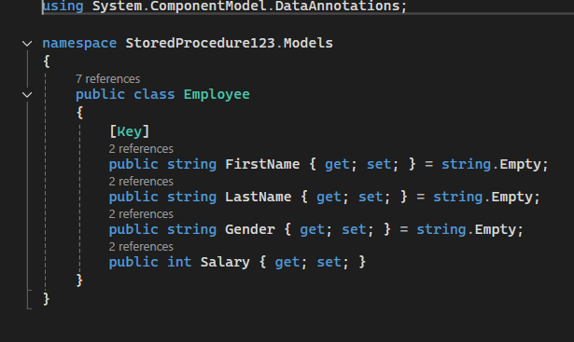
3. Add EmployeeController in Controllers folder  
   
4. Create Employee Folder with Index and DynamicSQL view  
   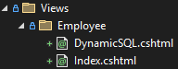
5. Modify _Layout in Shared folder to find Employee View  
   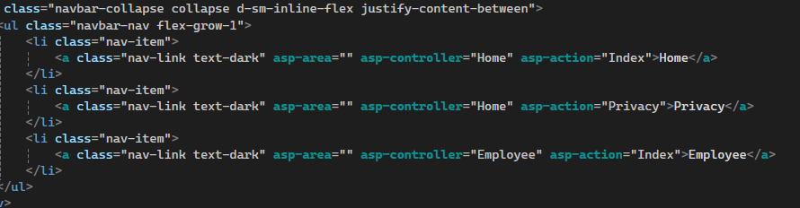
6. „Add-Migration init1“ + „Update-Database“ in Package Manager Console
7. Go to MS SQL Server Managment Studio, find „Leib92_SQL“ Database  
   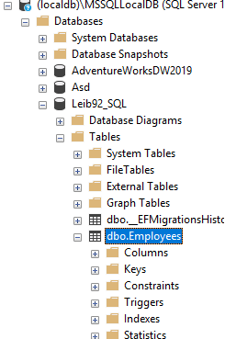
8. Edit „dbo.Employees“ table and add employees.  
   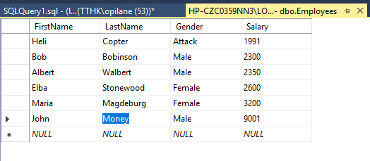
9. Create a Procedure in MS Sql  
   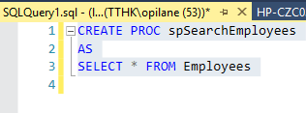Add DbContext to EmployeeController  
   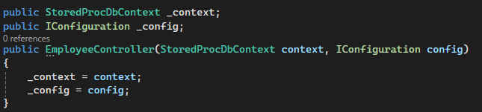
10. HttpGet for DynamicSQL  
    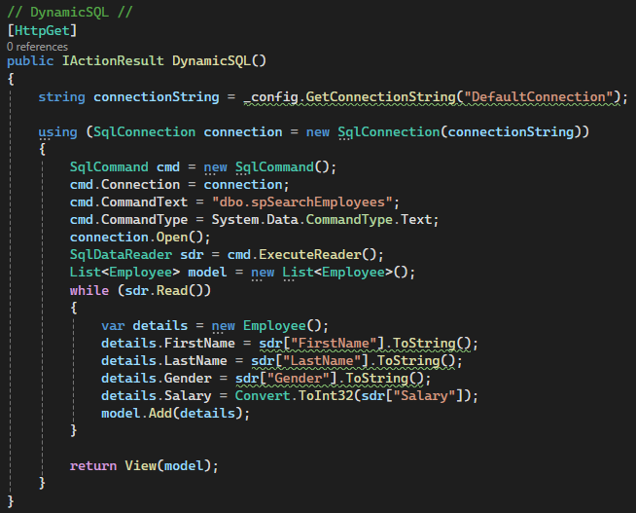
11. HttpPost for DynamicSQL  
    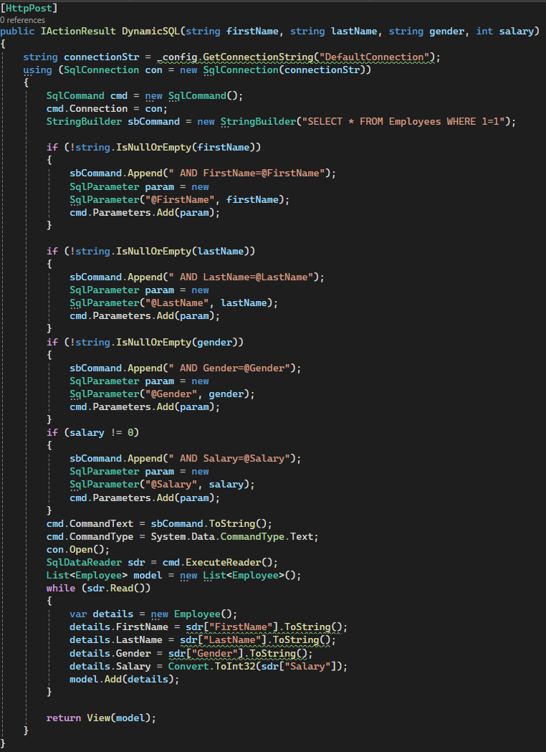

School Task: